Dynamic Programming
Dynamic programming is a technique that breaks the problems into sub-problems, and saves the result for future purposes so that we do not need to compute the result again. The sub problems are optimized to optimize the overall solution is known as optimal substructure property. The main use of dynamic programming is to solve optimization problems. Here, optimization problems mean that when we are trying to find out the minimum or the maximum solution of a problem. The dynamic programming guarantees to find the optimal solution of a problem if the solution exists.
The definition of dynamic programming says that it is a technique for solving a complex problem by first breaking into a collection of simpler sub problems, solving each sub problem just once, and then storing their solutions to avoid repetitive computations.
Let's understand this approach through an example.
Consider an example of the Fibonacci series. The following series is the Fibonacci series:
0, 1, 1, 2, 3, 5, 8, 13, 21, 34, 55, 89, 144, ,…
The numbers in the above series are not randomly calculated. Mathematically, we could write each of the terms using the below formula:
F(n) = F(n-1) + F(n-2),
With the base values F(0) = 0, and F(1) = 1. To calculate the other numbers, we follow the above relationship. For example, F(2) is the sum f(0) and f(1), which is equal to 1.

How can we calculate F(20)?
The F(20) term will be calculated using the nth formula of the Fibonacci series. The below figure shows that how F(20) is calculated.
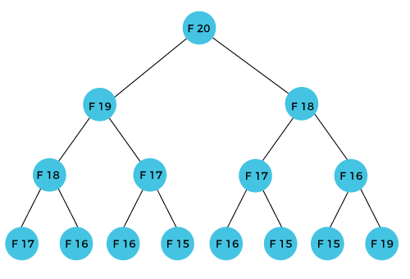
As we can observe in the above figure that F(20) is calculated as the sum of F(19) and F(18). In the dynamic programming approach, we try to divide the problem into the similar sub problems. We are following this approach in the above case where F(20) into the similar sub problems, i.e., F(19) and F(18). If we recap the definition of dynamic programming that it says the similar sub problem should not be computed more than once. Still, in the above case, the sub problem is calculated twice. In the above example, F(18) is calculated two times; similarly, F(17) is also calculated twice. However, this technique is quite useful as it solves the similar sub problems, but we need to be cautious while storing the results because we are not particular about storing the result that we have computed once, then it can lead to a wastage of resources.
In the above example, if we calculate the F(18) in the right subtree, then it leads to the tremendous usage of resources and decreases the overall performance.
The solution to the above problem is to save the computed results in an array. First, we calculate F(16) and F(17) and save their values in an array. The F(18) is calculated by summing the values of F(17) and F(16), which are already saved in an array. The computed value of F(18) is saved in an array. The value of F(19) is calculated using the sum of F(18), and F(17), and their values are already saved in an array. The computed value of F(19) is stored in an array. The value of F(20) can be calculated by adding the values of F(19) and F(18), and the values of both F(19) and F(18) are stored in an array. The final computed value of F(20) is stored in an array.

How does the dynamic programming approach work?
The following are the steps that the dynamic programming follows:
- It breaks down the complex problem into simpler sub problems.
- It finds the optimal solution to these sub-problems.
- It stores the results of sub problems (memorization). The process of storing the results of sub problems is known as memorization.
- It reuses them so that same sub-problem is calculated more than once.
- Finally, calculate the result of the complex problem.
The above five steps are the basic steps for dynamic programming. The dynamic programming is applicable that are having properties such as:
Those problems that are have overlapping sub problems and optimal substructures. Here, optimal substructure means that the solution of optimization problems can be obtained by simply combining the optimal solution of all the sub problems.
In the case of dynamic programming, the space complexity would be increased as we are storing the intermediate results, but the time complexity would be decreased.

Approaches of dynamic programming
There are two approaches to dynamic programming:
- Top-down approach
- Bottom-up approach

Top-down approach
The top-down approach follows the memorization technique, while bottom-up approach follows the tabulation method. Here memorization is equal to the sum of recursion and caching. Recursion means calling the function itself, while caching means storing the intermediate results.
Advantages
- It is very easy to understand and implement.
- It solves the sub problems only when it is required.
- It is easy to debug.
Disadvantages
- It uses the recursion technique that occupies more memory in the call stack. Sometimes when the recursion is too deep, the stack overflow condition will occur.
- It occupies more memory that degrades the overall performance.

Bottom-Up approach
The bottom-up approach is also one of the techniques which can be used to implement the dynamic programming. It uses the tabulation technique to implement the dynamic programming approach. It solves the same kind of problems but it removes the recursion. If we remove the recursion, there is no stack overflow issue and no overhead of the recursive functions. In this tabulation technique, we solve the problems and store the results in a matrix.
The bottom-up is the approach used to avoid the recursion, thus saving the memory space. The bottom-up is an algorithm that starts from the beginning, whereas the recursive algorithm starts from the end and works backward. In the bottom-up approach, we start from the base case to find the answer for the end. As we know, the base cases in the Fibonacci series are 0 and 1. Since the bottom approach starts from the base cases, so we will start from 0 and 1.
Key points
- We solve all the smaller sub-problems that will be needed to solve the larger sub-problems then move to the larger problems using smaller sub-problems.
- We use for loop to iterate over the sub-problems.
- The bottom-up approach is also known as the tabulation or table filling method.
Let's understand through an example.
Suppose we have an array that has 0 and 1 values at a[0] and a[1] positions, respectively shown as below:
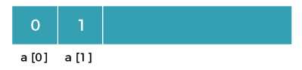
Since the bottom-up approach starts from the lower values, so the values at a[0] and a[1] are added to find the value of a[2] shown as below:
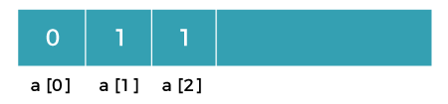
The value of a[3] will be calculated by adding a[1] and a[2], and it becomes 2 shown as below:
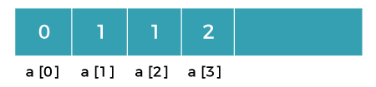
The value of a[4] will be calculated by adding a[2] and a[3], and it becomes 3 shown as below:
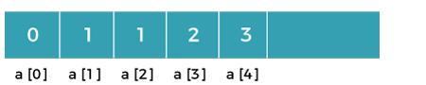
The value of a[5] will be calculated by adding the values of a[4] and a[3], and it becomes 5 shown as below:
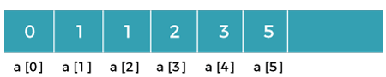
Let's understand through the diagrammatic representation.
Initially, the first two values, i.e., 0 and 1 can be represented as:
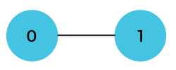
When i=2 then the values 0 and 1 are added shown as below:
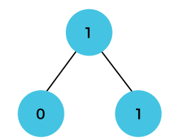
When i=3 then the values 1and 1 is added shown as below:
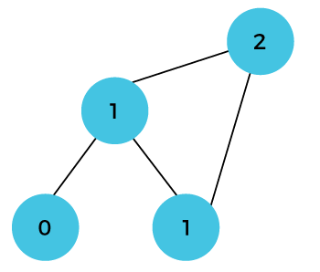
When i=4 then the values 2 and 1 are added shown as below
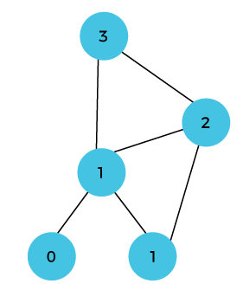
When i=5, then the values 3 and 2 are added shown as below
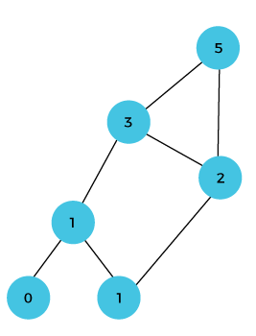
In the above case, we are starting from the bottom and reaching to the top

 | Dynamic | Greedy
Definition | It is used to obtain the optimum solution. | It is also used to obtain the optimum solution.
Feasibility | There is no special set of feasible solutions in this method. | In a greedy method, the optimum solution is obtained from the feasible set of solutions.
Recursion | Dynamic programming considers all the possible sequences in order to obtain the optimum solution. | In the greedy method, the optimum solution is obtained without revising the previously generated solutions.
Principle of optimality | It guarantees that it will generate the optimum solution using the principle of optimality. | It does not guarantee that it will generate the optimum solution.
Memoization | It creates the lookup table to store the results of the sub problems that occupy the memory space. | It is more efficient in terms of memory as it does not create any table to store the previous states.
Time Complexity | Dynamic programming is slower than the greedy method, like Bellman-Ford algorithm takes O(VE) time. | Greedy methods are faster than dynamic programming like Dijkstra's shortest path algorithm takes (ElogV + VlogV) time.
Method | The dynamic programming uses the bottom-up or top-down approach by breaking down a complex problem into simpler problems. | The greedy method always computes the solution in a sequence manner, and it does not look at the previous states.
Example 0/1 | knapsack problem | Fractional knapsack

Divide and Conquer Method vs. Dynamic Programming
Divide & Conquer | Dynamic
It involves three steps at each level of recursion:  Divide the problem into a number of sub problems.  Conquer the sub problems by solving them recursively.  Combine the solution to the sub problems into the solution for original sub problems. | It involves the sequence of four steps:  - Characterize the structure of optimal solutions.  - Recursively defines the values of optimal solutions.  - Compute the value of optimal solutions in a Bottom-up minimum.  - Construct an Optimal Solution from computed information.
2. It is Recursive. | 2. It is non Recursive.
3. It does more work on sub problems and hence has more time consumption. | 3. It solves sub problems only once and then stores in the table.
4. It is a top-down approach. | 4. It is a Bottom-up approach.
5. In this sub problems are independent of each other. | 5. In this sub problems are interdependent.
6. For example: Merge Sort & Binary Search etc. | 6. For example: Matrix Multiplication.

0/1 Knapsack problem
Here knapsack is like a container or a bag. Suppose we have given some items which have some weights or profits. We have to put some items in the knapsack in such a way that total value produces a maximum profit.
For example, the weight of the container is 20 kg. We have to select the items in such a way that the sum of the weight of items should be either smaller than or equal to the weight of the container, and the profit should be maximum.
There are two types of knapsack problems:
- 0/1 knapsack problem
- Fractional knapsack problem

What is the 0/1 knapsack problem?
The 0/1 knapsack problem means that the items are either completely or no items are filled in a knapsack. For example, we have two items having weights 2kg and 3kg, respectively. If we pick the 2kg item then we cannot pick 1kg item from the 2kg item (item is not divisible); we have to pick the 2kg item completely. This is a 0/1 knapsack problem in which either we pick the item completely or we will pick that item. The 0/1 knapsack problem is solved by the dynamic programming.

What is the fractional knapsack problem?
The fractional knapsack problem means that we can divide the item. For example, we have an item of 3 kg then we can pick the item of 2 kg and leave the item of 1 kg. The fractional knapsack problem is solved by the Greedy approach.

Example of 0/1 knapsack problem.
Consider the problem having weights and profits are:
Weights: {3, 4, 6, 5}
Profits: {2, 3, 1, 4}
The weight of the knapsack is 8 kg
The number of items is 4
The above problem can be solved by using the following method:
Xi = {1, 0, 0, 1}
= {0, 0, 0, 1}
= {0, 1, 0, 1}
The above are the possible combinations. 1 denotes that the item is completely picked and 0 means that no item is picked. Since there are 4 items so possible combinations will be:
2⁴ = 16
So there are 16 possible combinations that can be made by using the above problem. Once all the combinations are made, we have to select the combination that provides the maximum profit.
Another approach to solve the problem is dynamic programming approach. In dynamic programming approach, the complicated problem is divided into sub-problems, then we find the solution of a sub-problem and the solution of the sub-problem will be used to find the solution of a complex problem.

How this problem can be solved by using the Dynamic programming approach?
First,
We create a matrix shown as below:
0 | 1 | 2 | 3 | 4 | 5 | 6 | 7 | 8
0
1
2
3
4
In the above matrix, columns represent the weight, i.e., 8. The rows represent the profits and weights of items. Here we have not taken the weight 8 directly, problem is divided into sub-problems, i.e., 0, 1, 2, 3, 4, 5, 6, 7, 8. The solution of the sub-problems would be saved in the cells and answer to the problem would be stored in the final cell. First, we write the weights in the ascending order and profits according to their weights shown as below
w_{i} = {3, 4, 5, 6}
p_{i} = {2, 3, 4, 1}
The first row and the first column would be 0 as there is no item for w=0
 | 0 | 1 | 2 | 3 | 4 | 5 | 6 | 7 | 8
0 | 0 | 0 | 0 | 0 | 0 | 0 | 0 | 0 | 0
1 | 0
2 | 0
3 | 0
4 | 0
When i=1, W=1
w₁ = 3;
Since we have only one item in the set having weight 3, but the capacity of the knapsack is 1. We cannot fill the item of 3kg in the knapsack of capacity 1 kg so add 0 at M[1][1] shown as below:

 | 0 | 1 | 2 | 3 | 4 | 5 | 6 | 7 | 8
0 | 0 | 0 | 0 | 0 | 0 | 0 | 0 | 0 | 0
1 | 0 | 0
2 | 0
3 | 0
4 | 0
When i = 1, W = 2
w₁ = 3; since we have only one item in the set having weight 3, but the capacity of the knapsack is 2. We cannot fill the item of 3kg in the knapsack of capacity 2 kg so add 0 at M[1][2] shown as below:
0 | 1 | 2 | 3 | 4 | 5 | 6 | 7 | 8
0 | 0 | 0 | 0 | 0 | 0 | 0 | 0 | 0 | 0
1 | 0 | 0 | 0
2 | 0
3 | 0
4 | 0
When i=1, W=3
w₁ = 3; Since we have only one item in the set having weight equal to 3, and weight of the knapsack is also 3; therefore, we can fill the knapsack with an item of weight equal to 3. We put profit corresponding to the weight 3, i.e., 2 at M[1][3] shown as below:
 | 0 | 1 | 2 | 3 | 4 | 5 | 6 | 7 | 8
0 | 0 | 0 | 0 | 0 | 0 | 0 | 0 | 0 | 0
1 | 0 | 0 | 0 | 2
2 | 0
3 | 0
4 | 0
When i=1, W = 4
_{W1} = 3; Since we have only one item in the set having weight equal to 3, and weight of the knapsack is 4; therefore, we can fill the knapsack with an item of weight equal to 3. We put profit corresponding to the weight 3, i.e., 2 at M[1][4] shown as below:
 | 0 | 1 | 2 | 3 | 4 | 5 | 6 | 7 | 8
0 | 0 | 0 | 0 | 0 | 0 | 0 | 0 | 0 | 0
1 | 0 | 0 | 0 | 2 | 2
2 | 0
3 | 0
4 | 0
When i=1, W = 5
_{W1} = 3; Since we have only one item in the set having weight equal to 3, and weight of the knapsack is 5; therefore, we can fill the knapsack with an item of weight equal to 3. We put profit corresponding to the weight 3, i.e., 2 at M[1][5] shown as below:
 | 0 | 1 | 2 | 3 | 4 | 5 | 6 | 7 | 8
0 | 0 | 0 | 0 | 0 | 0 | 0 | 0 | 0 | 0
1 | 0 | 0 | 0 | 2 | 2 | 2
2 | 0
3 | 0
4 | 0
When i =1, W=6
_{W1} = 3; Since we have only one item in the set having weight equal to 3, and weight of the knapsack is 6; therefore, we can fill the knapsack with an item of weight equal to 3. We put profit corresponding to the weight 3, i.e., 2 at M[1][6] shown as below:
 | 0 | 1 | 2 | 3 | 4 | 5 | 6 | 7 | 8
0 | 0 | 0 | 0 | 0 | 0 | 0 | 0 | 0 | 0
1 | 0 | 0 | 0 | 2 | 2 | 2 | 2
2 | 0
3 | 0
4 | 0
When i=1, W = 7
_{W1} = 3; Since we have only one item in the set having weight equal to 3, and weight of the knapsack is 7; therefore, we can fill the knapsack with an item of weight equal to 3. We put profit corresponding to the weight 3, i.e., 2 at M[1][7] shown as below:
 | 0 | 1 | 2 | 3 | 4 | 5 | 6 | 7 | 8
0 | 0 | 0 | 0 | 0 | 0 | 0 | 0 | 0 | 0
1 | 0 | 0 | 0 | 2 | 2 | 2 | 2 | 2
2 | 0
3 | 0
4 | 0
When i =1, W =8
When i =1, W =8
_{W1} = 3; Since we have only one item in the set having weight equal to 3, and weight of the knapsack is 8; therefore, we can fill the knapsack with an item of weight equal to 3. We put profit corresponding to the weight 3, i.e., 2 at M [1][8] shown as below:
 | 0 | 1 | 2 | 3 | 4 | 5 | 6 | 7 | 8
0 | 0 | 0 | 0 | 0 | 0 | 0 | 0 | 0 | 0
1 | 0 | 0 | 0 | 2 | 2 | 2 | 2 | 2 | 2
2 | 0
3 | 0
4 | 0
Now the value of 'i' gets incremented, and becomes 2.
When i =2, W = 1
The weight corresponding to the value 2 is 4, i.e., w₂ = 4. Since we have only one item in the set having weight equal to 4, and the weight of the knapsack is 1. We cannot put the item of weight 4 in a knapsack, so we add 0 at M [2][1] shown as below:
 | 0 | 1 | 2 | 3 | 4 | 5 | 6 | 7 | 8
0 | 0 | 0 | 0 | 0 | 0 | 0 | 0 | 0 | 0
1 | 0 | 0 | 0 | 2 | 2 | 2 | 2 | 2 | 2
2 | 0 | 0
3 | 0
4 | 0
When i =2, W = 2
The weight corresponding to the value 2 is 4, i.e., w₂ = 4. Since we have only one item in the set having weight equal to 4, and the weight of the knapsack is 2. We cannot put the item of weight 4 in a knapsack, so we add 0 at M [2][2] shown as below:
 | 0 | 1 | 2 | 3 | 4 | 5 | 6 | 7 | 8
0 | 0 | 0 | 0 | 0 | 0 | 0 | 0 | 0 | 0
1 | 0 | 0 | 0 | 2 | 2 | 2 | 2 | 2 | 2
2 | 0 | 0 | 0
3 | 0
4 | 0
When i =2, W = 3
The weight corresponding to the value 2 is 4, i.e., w₂ = 4. Since we have two items in the set having weights 3 and 4, and the weight of the knapsack is 3. We can put the item of weight 3 in a knapsack, so we add 2 at M[2][3] shown as below:
 | 0 | 1 | 2 | 3 | 4 | 5 | 6 | 7 | 8
0 | 0 | 0 | 0 | 0 | 0 | 0 | 0 | 0 | 0
1 | 0 | 0 | 0 | 2 | 2 | 2 | 2 | 2 | 2
2 | 0 | 0 | 0 | 2
3 | 0
4 | 0
When i =2, W = 4
The weight corresponding to the value 2 is 4, i.e., w₂ = 4. Since we have two items in the set having weights 3 and 4, and the weight of the knapsack is 4. We can put item of weight 4 in a knapsack as the profit corresponding to weight 4 is more than the item having weight 3, so we add 3 at M[2][4] shown as below:
 | 0 | 1 | 2 | 3 | 4 | 5 | 6 | 7 | 8
0 | 0 | 0 | 0 | 0 | 0 | 0 | 0 | 0 | 0
1 | 0 | 0 | 0 | 2 | 2 | 2 | 2 | 2 | 2
2 | 0 | 0 | 0 | 2 | 3
3 | 0
4 | 0
When i = 2, W = 5
The weight corresponding to the value 2 is 4, i.e., w₂ = 4. Since we have two items in the set having weights 3 and 4, and the weight of the knapsack is 5. We can put item of weight 4 in a knapsack and the profit corresponding to weight is 3, so we add 3 at M [2][5] shown as below:
 | 0 | 1 | 2 | 3 | 4 | 5 | 6 | 7 | 8
0 | 0 | 0 | 0 | 0 | 0 | 0 | 0 | 0 | 0
1 | 0 | 0 | 0 | 2 | 2 | 2 | 2 | 2 | 2
2 | 0 | 0 | 0 | 2 | 3 | 3
3 | 0
4 | 0
When i = 2, W = 6
The weight corresponding to the value 2 is 4, i.e., w₂ = 4. Since we have two items in the set having weights 3 and 4, and the weight of the knapsack is 6. We can put item of weight 4 in a knapsack and the profit corresponding to weight is 3, so we add 3 at M[2][6] shown as below:
 | 0 | 1 | 2 | 3 | 4 | 5 | 6 | 7 | 8
0 | 0 | 0 | 0 | 0 | 0 | 0 | 0 | 0 | 0
1 | 0 | 0 | 0 | 2 | 2 | 2 | 2 | 2 | 2
2 | 0 | 0 | 0 | 2 | 3 | 3 | 3
3 | 0
4 | 0
When i = 2, W = 7
The weight corresponding to the value 2 is 4, i.e., w₂ = 4. Since we have two items in the set having weights 3 and 4, and the weight of the knapsack is 7. We can put item of weight 4 and 3 in a knapsack and the profits corresponding to weights are 2 and 3; therefore, the total profit is 5, so we add 5 at M[2][7] shown as below:
 | 0 | 1 | 2 | 3 | 4 | 5 | 6 | 7 | 8
0 | 0 | 0 | 0 | 0 | 0 | 0 | 0 | 0 | 0
1 | 0 | 0 | 0 | 2 | 2 | 2 | 2 | 2 | 2
2 | 0 | 0 | 0 | 0 | 3 | 3 | 3 | 5
3 | 0
4 | 0
When i = 2, W = 8
The weight corresponding to the value 2 is 4, i.e., w₂ = 4. Since we have two items in the set having weights 3 and 4, and the weight of the knapsack is 7. We can put item of weight 4 and 3 in a knapsack and the profits corresponding to weights are 2 and 3; therefore, the total profit is 5, so we add 5 at M[2][7] shown as below:
 | 0 | 1 | 2 | 3 | 4 | 5 | 6 | 7 | 8
0 | 0 | 0 | 0 | 0 | 0 | 0 | 0 | 0 | 0
1 | 0 | 0 | 0 | 2 | 2 | 2 | 2 | 2 | 2
2 | 0 | 0 | 0 | 2 | 3 | 3 | 3 | 5 | 5
3 | 0
4 | 0
Now the value of 'i' gets incremented, and becomes 3.
When i = 3, W = 1
The weight corresponding to the value 3 is 5, i.e., w₃ = 5. Since we have three items in the set having weights 3, 4, and 5, and the weight of the knapsack is 1. We cannot put neither of the items in a knapsack, so we add 0 at M[3][1] shown as below:
 | 0 | 1 | 2 | 3 | 4 | 5 | 6 | 7 | 8
0 | 0 | 0 | 0 | 0 | 0 | 0 | 0 | 0 | 0
1 | 0 | 0 | 0 | 2 | 2 | 2 | 2 | 2 | 2
2 | 0 | 0 | 0 | 2 | 3 | 3 | 3 | 5 | 5
3 | 0 | 0
4 | 0
When i = 3, W = 2
The weight corresponding to the value 3 is 5, i.e., w₃ = 5. Since we have three items in the set having weight 3, 4, and 5, and the weight of the knapsack is 1. We cannot put neither of the items in a knapsack, so we add 0 at M[3][2] shown as below:
 | 0 | 1 | 2 | 3 | 4 | 5 | 6 | 7 | 8
0 | 0 | 0 | 0 | 0 | 0 | 0 | 0 | 0 | 0
1 | 0 | 0 | 0 | 2 | 2 | 2 | 2 | 2 | 2
2 | 0 | 0 | 0 | 2 | 3 | 3 | 3 | 5 | 5
3 | 0 | 0 | 0
4 | 0
When i = 3, W = 3
The weight corresponding to the value 3 is 5, i.e., w₃ = 5. Since we have three items in the set of weight 3, 4, and 5 respectively and weight of the knapsack is 3. The item with a weight 3 can be put in the knapsack and the profit corresponding to the item is 2, so we add 2 at M[3][3] shown as below:
 | 0 | 1 | 2 | 3 | 4 | 5 | 6 | 7 | 8
0 | 0 | 0 | 0 | 0 | 0 | 0 | 0 | 0 | 0
1 | 0 | 0 | 0 | 2 | 2 | 2 | 2 | 2 | 2
2 | 0 | 0 | 0 | 2 | 3 | 3 | 3 | 5 | 5
3 | 0 | 0 | 0 | 2
4 | 0
When i = 3, W = 4
The weight corresponding to the value 3 is 5, i.e., w₃ = 5. Since we have three items in the set of weight 3, 4, and 5 respectively, and weight of the knapsack is 4. We can keep the item of either weight 3 or 4; the profit (3) corresponding to the weight 4 is more than the profit corresponding to the weight 3 so we add 3 at M[3][4] shown as below:
 | 0 | 1 | 2 | 3 | 4 | 5 | 6 | 7 | 8
0 | 0 | 0 | 0 | 0 | 0 | 0 | 0 | 0 | 0
1 | 0 | 0 | 0 | 2 | 2 | 2 | 2 | 2 | 2
2 | 0 | 0 | 0 | 2 | 3 | 3 | 3 | 5 | 5
3 | 0 | 0 | 0 | 1 | 3
4 | 0
When i = 3, W = 5
The weight corresponding to the value 3 is 5, i.e., w₃ = 5. Since we have three items in the set of weight 3, 4, and 5 respectively, and weight of the knapsack is 5. We can keep the item of either weight 3, 4 or 5; the profit (3) corresponding to the weight 4 is more than the profits corresponding to the weight 3 and 5 so we add 3 at M[3][5] shown as below:
 | 0 | 1 | 2 | 3 | 4 | 5 | 6 | 7 | 8
0 | 0 | 0 | 0 | 0 | 0 | 0 | 0 | 0 | 0
1 | 0 | 0 | 0 | 2 | 2 | 2 | 2 | 2 | 2
2 | 0 | 0 | 0 | 2 | 3 | 3 | 3 | 5 | 5
3 | 0 | 0 | 0 | 1 | 3 | 3
4 | 0
When i =3, W = 6
The weight corresponding to the value 3 is 5, i.e., w₃ = 5. Since we have three items in the set of weight 3, 4, and 5 respectively, and weight of the knapsack is 6. We can keep the item of either weight 3, 4 or 5; the profit (3) corresponding to the weight 4 is more than the profits corresponding to the weight 3 and 5 so we add 3 at M[3][6] shown as below:
 | 0 | 1 | 2 | 3 | 4 | 5 | 6 | 7 | 8
0 | 0 | 0 | 0 | 0 | 0 | 0 | 0 | 0 | 0
1 | 0 | 0 | 0 | 2 | 2 | 2 | 2 | 2 | 2
2 | 0 | 0 | 0 | 2 | 3 | 3 | 3 | 5 | 5
3 | 0 | 0 | 0 | 1 | 3 | 3 | 3
4 | 0
When i =3, W = 7
The weight corresponding to the value 3 is 5, i.e., w₃ = 5. Since we have three items in the set of weight 3, 4, and 5 respectively, and weight of the knapsack is 7. In this case, we can keep both the items of weight 3 and 4, the sum of the profit would be equal to (2 + 3), i.e., 5, so we add 5 at M[3][7] shown as below:
 | 0 | 1 | 2 | 3 | 4 | 5 | 6 | 7 | 8
0 | 0 | 0 | 0 | 0 | 0 | 0 | 0 | 0 | 0
1 | 0 | 0 | 0 | 2 | 2 | 2 | 2 | 2 | 2
2 | 0 | 0 | 0 | 2 | 3 | 3 | 3 | 5 | 5
3 | 0 | 0 | 0 | 1 | 3 | 3 | 3 | 5
4 | 0
When i = 3, W = 8
The weight corresponding to the value 3 is 5, i.e., w₃ = 5. Since we have three items in the set of weight 3, 4, and 5 respectively, and the weight of the knapsack is 8. In this case, we can keep both the items of weight 3 and 4, the sum of the profit would be equal to (2 + 3), i.e., 5, so we add 5 at M[3][8] shown as below:
 | 0 | 1 | 2 | 3 | 4 | 5 | 6 | 7 | 8
0 | 0 | 0 | 0 | 0 | 0 | 0 | 0 | 0 | 0
1 | 0 | 0 | 0 | 2 | 2 | 2 | 2 | 2 | 2
2 | 0 | 0 | 0 | 2 | 3 | 3 | 3 | 5 | 5
3 | 0 | 0 | 0 | 1 | 3 | 3 | 3 | 5 | 5
4 | 0
Now the value of 'i' gets incremented and becomes 4.
When i = 4, W = 1
The weight corresponding to the value 4 is 6, i.e., w₄ = 6. Since we have four items in the set of weights 3, 4, 5, and 6 respectively, and the weight of the knapsack is 1. The weight of all the items is more than the weight of the knapsack, so we cannot add any item in the knapsack; Therefore, we add 0 at M[4][1] shown as below:
 | 0 | 1 | 2 | 3 | 4 | 5 | 6 | 7 | 8
0 | 0 | 0 | 0 | 0 | 0 | 0 | 0 | 0 | 0
1 | 0 | 0 | 0 | 2 | 2 | 2 | 2 | 2 | 2
2 | 0 | 0 | 0 | 2 | 3 | 3 | 3 | 5 | 5
3 | 0 | 0 | 0 | 1 | 3 | 3 | 3 | 5 | 5
4 | 0 | 0
When i = 4, W = 2
The weight corresponding to the value 4 is 6, i.e., w₄ = 6. Since we have four items in the set of weights 3, 4, 5, and 6 respectively, and the weight of the knapsack is 2. The weight of all the items is more than the weight of the knapsack, so we cannot add any item in the knapsack; Therefore, we add 0 at M[4][2] shown as below:
 | 0 | 1 | 2 | 3 | 4 | 5 | 6 | 7 | 8
0 | 0 | 0 | 0 | 0 | 0 | 0 | 0 | 0 | 0
1 | 0 | 0 | 0 | 2 | 2 | 2 | 2 | 2 | 2
2 | 0 | 0 | 0 | 2 | 3 | 3 | 3 | 5 | 5
3 | 0 | 0 | 0 | 1 | 3 | 3 | 3 | 5 | 5
4 | 0 | 0 | 0
When i = 4, W = 3
The weight corresponding to the value 4 is 6, i.e., w₄ = 6. Since we have four items in the set of weights 3, 4, 5, and 6 respectively, and the weight of the knapsack is 3. The item with a weight 3 can be put in the knapsack and the profit corresponding to the weight 4 is 2, so we will add 2 at M[4][3] shown as below:
 | 0 | 1 | 2 | 3 | 4 | 5 | 6 | 7 | 8
0 | 0 | 0 | 0 | 0 | 0 | 0 | 0 | 0 | 0
1 | 0 | 0 | 0 | 2 | 2 | 2 | 2 | 2 | 2
2 | 0 | 0 | 0 | 2 | 3 | 3 | 3 | 5 | 5
3 | 0 | 0 | 0 | 1 | 3 | 3 | 3 | 5 | 5
4 | 0 | 0 | 0 | 2
When i = 4, W = 4
The weight corresponding to the value 4 is 6, i.e., w₄ = 6. Since we have four items in the set of weights 3, 4, 5, and 6 respectively, and the weight of the knapsack is 4. The item with a weight 4 can be put in the knapsack and the profit corresponding to the weight 4 is 3, so we will add 3 at M[4][4] shown as below:
0 | 1 | 2 | 3 | 4 | 5 | 6 | 7 | 8
0 | 0 | 0 | 0 | 0 | 0 | 0 | 0 | 0 | 0
1 | 0 | 0 | 0 | 2 | 2 | 2 | 2 | 2 | 2
2 | 0 | 0 | 0 | 2 | 3 | 3 | 3 | 5 | 5
3 | 0 | 0 | 0 | 1 | 3 | 3 | 3 | 5 | 5
4 | 0 | 0 | 0 | 2 | 3
When i = 4, W = 5
The weight corresponding to the value 4 is 6, i.e., w₄ = 6. Since we have four items in the set of weights 3, 4, 5, and 6 respectively, and the weight of the knapsack is 5. The item with a weight 4 can be put in the knapsack and the profit corresponding to the weight 4 is 3, so we will add 3 at M[4][5] shown as below:
 | 0 | 1 | 2 | 3 | 4 | 5 | 6 | 7 | 8
0 | 0 | 0 | 0 | 0 | 0 | 0 | 0 | 0 | 0
1 | 0 | 0 | 0 | 2 | 2 | 2 | 2 | 2 | 2
2 | 0 | 0 | 0 | 2 | 3 | 3 | 3 | 5 | 5
3 | 0 | 0 | 0 | 1 | 3 | 3 | 3 | 5 | 5
4 | 0 | 0 | 0 | 2 | 3 | 3
When i = 4, W = 6
The weight corresponding to the value 4 is 6, i.e., w₄ = 6. Since we have four items in the set of weights 3, 4, 5, and 6 respectively, and the weight of the knapsack is 6. In this case, we can put the items in the knapsack either of weight 3, 4, 5 or 6 but the profit, i.e., 4 corresponding to the weight 6 is highest among all the items; therefore, we add 4 at M[4][6] shown as below:
 | 0 | 1 | 2 | 3 | 4 | 5 | 6 | 7 | 8
0 | 0 | 0 | 0 | 0 | 0 | 0 | 0 | 0 | 0
1 | 0 | 0 | 0 | 2 | 2 | 2 | 2 | 2 | 2
2 | 0 | 0 | 0 | 2 | 3 | 3 | 3 | 5 | 5
3 | 0 | 0 | 0 | 1 | 3 | 3 | 3 | 5 | 5
4 | 0 | 0 | 0 | 2 | 3 | 3 | 4
When i = 4, W = 7
The weight corresponding to the value 4 is 6, i.e., w₄ = 6. Since we have four items in the set of weights 3, 4, 5, and 6 respectively, and the weight of the knapsack is 7. Here, if we add two items of weights 3 and 4 then it will produce the maximum profit, i.e., (2 + 3) equals to 5, so we add 5 at M[4][7] shown as below:
 | 0 | 1 | 2 | 3 | 4 | 5 | 6 | 7 | 8
0 | 0 | 0 | 0 | 0 | 0 | 0 | 0 | 0 | 0
1 | 0 | 0 | 0 | 2 | 2 | 2 | 2 | 2 | 2
2 | 0 | 0 | 0 | 2 | 3 | 3 | 3 | 5 | 5
3 | 0 | 0 | 0 | 2 | 3 | 3 | 3 | 5 | 5
4 | 0 | 0 | 0 | 2 | 3 | 3 | 4 | 5
When i = 4, W = 8
The weight corresponding to the value 4 is 6, i.e., w₄ = 6. Since we have four items in the set of weights 3, 4, 5, and 6 respectively, and the weight of the knapsack is 8. Here, if we add two items of weights 3 and 4 then it will produce the maximum profit, i.e., (2 + 3) equals to 5, so we add 5 at M[4][8] shown as below:
 | 0 | 1 | 2 | 3 | 4 | 5 | 6 | 7 | 8
0 | 0 | 0 | 0 | 0 | 0 | 0 | 0 | 0 | 0
1 | 0 | 0 | 0 | 2 | 2 | 2 | 2 | 2 | 2
2 | 0 | 0 | 0 | 2 | 3 | 3 | 3 | 5 | 5
3 | 0 | 0 | 0 | 2 | 3 | 3 | 3 | 5 | 5
4 | 0 | 0 | 0 | 2 | 3 | 3 | 4 | 5 | 5
As we can observe in the above table that 5 is the maximum profit among all the entries. The pointer points to the last row and the last column having 5 value. Now we will compare 5 value with the previous row; if the previous row, i.e., i = 3 contains the same value 5 then the pointer will shift upwards. Since the previous row contains the value 5 so the pointer will be shifted upwards as shown in the below table:
 | 0 | 1 | 2 | 3 | 4 | 5 | 6 | 7 | 8
0 | 0 | 0 | 0 | 0 | 0 | 0 | 0 | 0 | 0
1 | 0 | 0 | 0 | 2 | 2 | 2 | 2 | 2 | 2
2 | 0 | 0 | 0 | 2 | 3 | 3 | 3 | 5 | 5
3 | 0 | 0 | 0 | 2 | 3 | 3 | 3 | 5 | 5
4 | 0 | 0 | 0 | 2 | 3 | 3 | 4 | 5 | 5
Again, we will compare the value 5 from the above row, i.e., i = 2. Since the above row contains the value 5 so the pointer will again be shifted upwards as shown in the below table:
 | 0 | 1 | 2 | 3 | 4 | 5 | 6 | 7 | 8
0 | 0 | 0 | 0 | 0 | 0 | 0 | 0 | 0 | 0
1 | 0 | 0 | 0 | 2 | 2 | 2 | 2 | 2 | 2
2 | 0 | 0 | 0 | 2 | 3 | 3 | 3 | 5 | 5
3 | 0 | 0 | 0 | 2 | 3 | 3 | 3 | 5 | 5
4 | 0 | 0 | 0 | 2 | 3 | 3 | 4 | 5 | 5
Again, we will compare the value 5 from the above row, i.e., i = 1. Since the above row does not contain the same value so we will consider the row i=1, and the weight corresponding to the row is 4. Therefore, we have selected the weight 4 and we have rejected the weights 5 and 6 shown below:
x = { 1, 0, 0}
The profit corresponding to the weight is 3. Therefore, the remaining profit is (5 - 3) equals to 2. Now we will compare this value 2 with the row i = 2. Since the row (i = 1) contains the value 2; therefore, the pointer shifted upwards shown below:
 | 0 | 1 | 2 | 3 | 4 | 5 | 6 | 7 | 8
0 | 0 | 0 | 0 | 0 | 0 | 0 | 0 | 0 | 0
1 | 0 | 0 | 0 | 2 | 2 | 2 | 2 | 2 | 2
2 | 0 | 0 | 0 | 2 | 3 | 3 | 3 | 5 | 5
3 | 0 | 0 | 0 | 2 | 3 | 3 | 3 | 5 | 5
4 | 0 | 0 | 0 | 2 | 3 | 3 | 4 | 5 | 5
Again we compare the value 2 with a above row, i.e., i = 1. Since the row i =0 does not contain the value 2, so row i = 1 will be selected and the weight corresponding to the i = 1 is 3 shown below:
X = {1, 1, 0, 0}
The profit corresponding to the weight is 2. Therefore, the remaining profit is 0. We compare 0 value with the above row. Since the above row contains a 0 value but the profit corresponding to this row is 0. In this problem, two weights are selected, i.e., 3 and 4 to maximize the profit.

Floyd-Warshall Algorithm
Let the vertices of G be V = {1, 2........n} and consider a subset {1, 2........k} of vertices for some k. For any pair of vertices i, j ∈ V, considered all paths from i to j whose intermediate vertices are all drawn from {1, 2.......k}, and let p be a minimum weight path from amongst them. The Floyd-Warshall algorithm exploits a link between path p and shortest paths from i to j with all intermediate vertices in the set {1, 2.......k-1}. The link depends on whether or not k is an intermediate vertex of path p.
If k is not an intermediate vertex of path p, then all intermediate vertices of path p are in the set {1, 2........k-1}. Thus, the shortest path from vertex i to vertex j with all intermediate vertices in the set {1, 2.......k-1} is also the shortest path i to j with all intermediate vertices in the set {1, 2.......k}.
If k is an intermediate vertex of path p, then we break p down into i → k → j.
Let d_{ij}^{(k)} be the weight of the shortest path from vertex i to vertex j with all intermediate vertices in the set {1, 2.......k}.
A recursive definition is given by
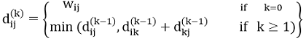
FLOYD - WARSHALL (W)
1. n ← rows [W].
2. D⁰ ← W
3. for k ← 1 to n
4. do for i ← 1 to n
5. do for j ← 1 to n
6. do d_{ij}^{(k)} ← min (d_{ij}^{(k-1)},d_{ik}^{(k-1)}+d_{kj}^{(k-1)} )
7. return D^{(n)}
The strategy adopted by the Floyd-Warshall algorithm is Dynamic Programming. The running time of the Floyd-Warshall algorithm is determined by the triply nested for loops of lines 3-6. Each execution of line 6 takes O (1) time. The algorithm thus runs in time θ(n³ ).
Example: Apply Floyd-Warshall algorithm for constructing the shortest path. Show that matrices D^{(k)} and π^{(k)} computed by the Floyd-Warshall algorithm for the graph.
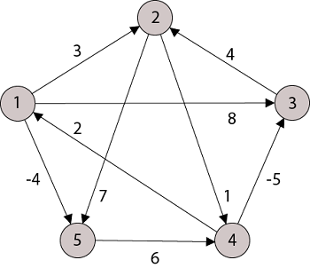
Solution:
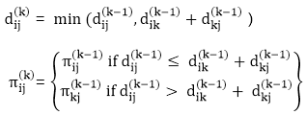
Step (i) When k = 0
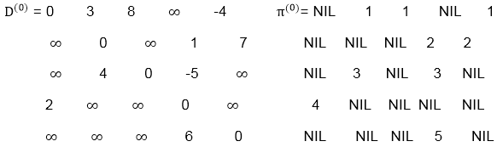
Step (ii) When k =1
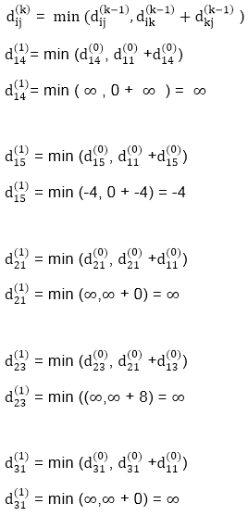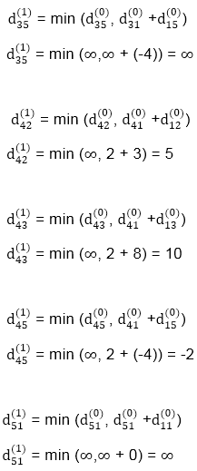
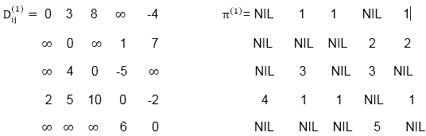
Step (iii) When k = 2
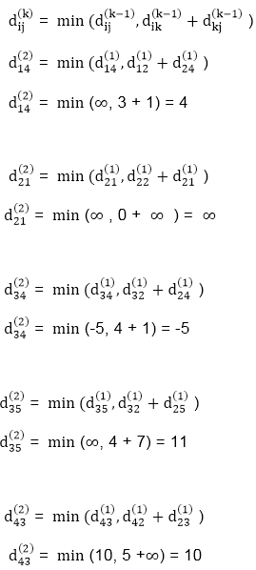
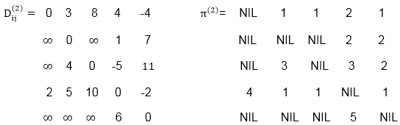
Step (iv) When k = 3
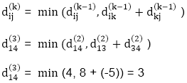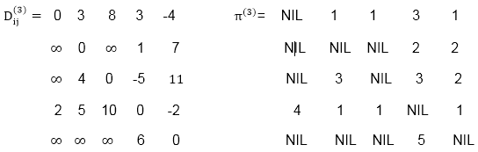
Step (v) When k = 4
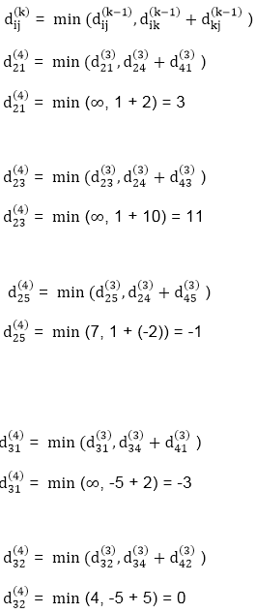
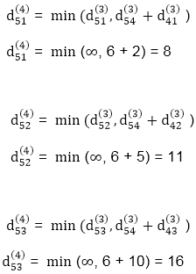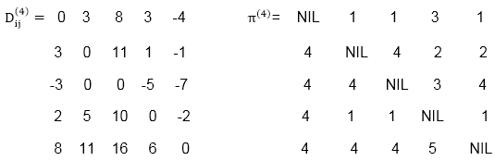
Step (vi) When k = 5
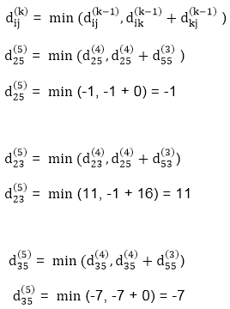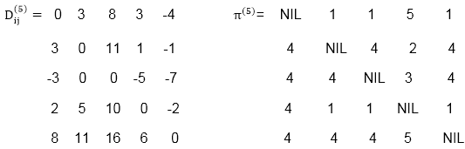
TRANSITIVE- CLOSURE (G)
1. n ← |V[G]|
2. for i ← 1 to n
3. do for j ← 1 to n
4. do if i = j or (i, j) ∈ E [G]
5. the ← 1
6. else ← 0
7. for k ← 1 to n
8. do for i ← 1 to n
9. do for j ← 1 to n
10. dod _{ij}^{(k)} ← 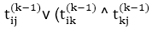
11. Return T^{(n)}.

Binary Search tree
In this article, we will discuss the Binary search tree. This article will be very helpful and informative to the students with technical background as it is an important topic of their course.
Before moving directly to the binary search tree, let's first see a brief description of the tree.

What is a tree?
A tree is a kind of data structure that is used to represent the data in hierarchical form. It can be defined as a collection of objects or entities called as nodes that are linked together to simulate a hierarchy. Tree is a non-linear data structure as the data in a tree is not stored linearly or sequentially.
Now, let's start the topic, the Binary Search tree.

What is a Binary Search tree?
A binary search tree follows some order to arrange the elements. In a Binary search tree, the value of left node must be smaller than the parent node, and the value of right node must be greater than the parent node. This rule is applied recursively to the left and right sub trees of the root.
Let's understand the concept of Binary search tree with an example.
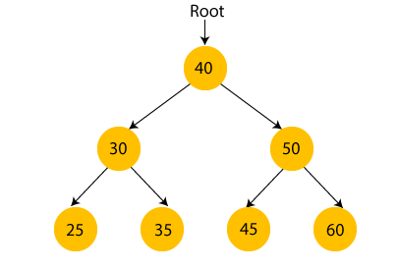
In the above figure, we can observe that the root node is 40, and all the nodes of the left sub tree are smaller than the root node, and all the nodes of the right sub tree are greater than the root node.
Similarly, we can see the left child of root node is greater than its left child and smaller than its right child. So, it also satisfies the property of binary search tree. Therefore, we can say that the tree in the above image is a binary search tree.
Suppose if we change the value of node 35 to 55 in the above tree, check whether the tree will be binary search tree or not.
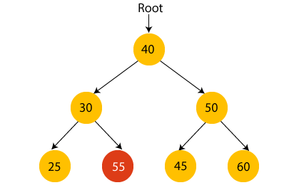
In the above tree, the value of root node is 40, which is greater than its left child 30 but smaller than right child of 30, i.e., 55. So, the above tree does not satisfy the property of Binary search tree. Therefore, the above tree is not a binary search tree.

Advantages of Binary search tree
- Searching an element in the Binary search tree is easy as we always have a hint that which sub tree has the desired element.
- As compared to array and linked lists, insertion and deletion operations are faster in BST.

Example of creating a binary search tree
Now, let's see the creation of binary search tree using an example.
Suppose the data elements are - 45, 15, 79, 90, 10, 55, 12, 20, 50
- First, we have to insert 45 into the tree as the root of the tree.
- Then, read the next element; if it is smaller than the root node, insert it as the root of the left subtree, and move to the next element.
- Otherwise, if the element is larger than the root node, then insert it as the root of the right subtree.
- Now, let's see the process of creating the Binary search tree using the given data element. The process of creating the BST is shown below -
- Step 1 - Insert 45.
- 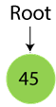
- Step 2 - Insert 15.
- As 15 is smaller than 45, so insert it as the root node of the left subtree.
- 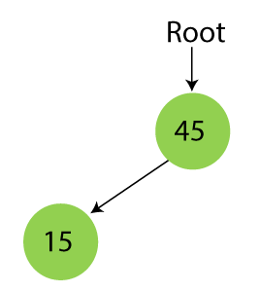
Step 3 - Insert 79.
As 79 is greater than 45, so insert it as the root node of the right subtree.
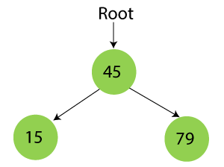
Step 4 - Insert 90.
90 is greater than 45 and 79, so it will be inserted as the right subtree of 79.
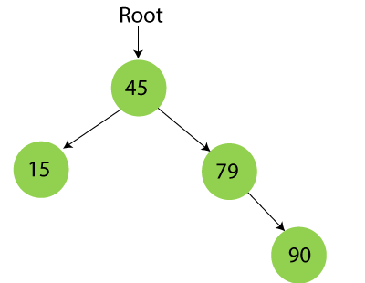
Step 5 - Insert 10.
10 is smaller than 45 and 15, so it will be inserted as a left subtree of 15.
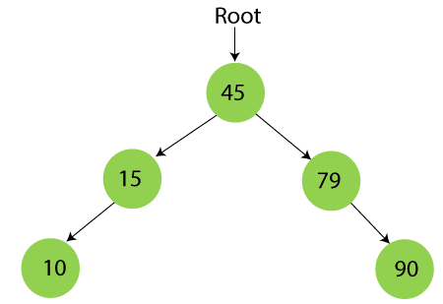
Step 6 - Insert 55.
55 is larger than 45 and smaller than 79, so it will be inserted as the left subtree of 79.
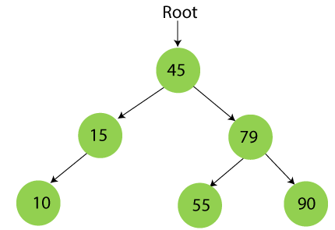
Step 7 - Insert 12.
12 is smaller than 45 and 15 but greater than 10, so it will be inserted as the right subtree of 10.
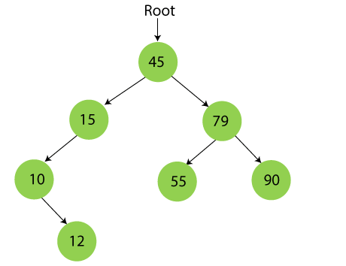
Step 8 - Insert 20.
20 is smaller than 45 but greater than 15, so it will be inserted as the right subtree of 15.
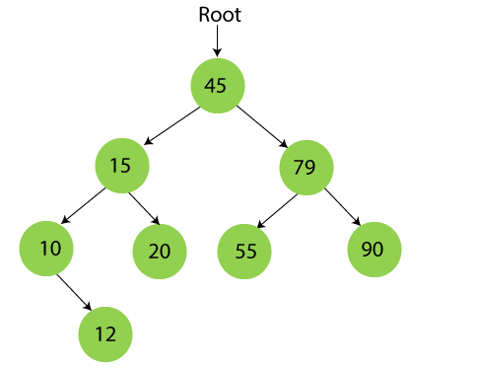
Step 9 - Insert 50.
50 is greater than 45 but smaller than 79 and 55. So, it will be inserted as a left subtree of 55.
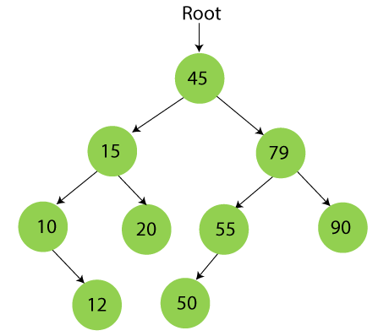
Now, the creation of binary search tree is completed. After that, let's move towards the operations that can be performed on Binary search tree.
We can perform insert, delete and search operations on the binary search tree.
Let's understand how a search is performed on a binary search tree.

Searching in Binary search tree
Searching means to find or locate a specific element or node in a data structure. In Binary search tree, searching a node is easy because elements in BST are stored in a specific order. The steps of searching a node in Binary Search tree are listed as follows -
- First, compare the element to be searched with the root element of the tree.
- If root is matched with the target element, then return the node's location.
- If it is not matched, then check whether the item is less than the root element, if it is smaller than the root element, then move to the left subtree.
- If it is larger than the root element, then move to the right subtree.
- Repeat the above procedure recursively until the match is found.
- If the element is not found or not present in the tree, then return NULL.
- Now, let's understand the searching in binary tree using an example. We are taking the binary search tree formed above. Suppose we have to find node 20 from the below tree.
Step1:
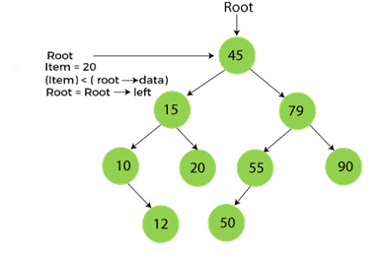
Step2:
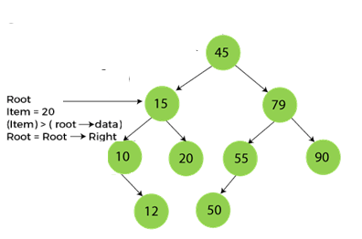
Step3
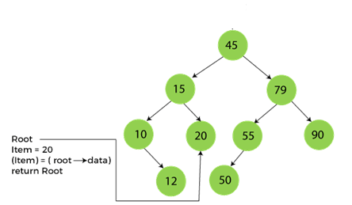
Now, let's see the algorithm to search an element in the Binary search tree

Algorithm to search an element in Binary search tree
- Search (root, item)
- Step 1 - if (item = root → data) or (root = NULL)
- return root
- else if (item < root → data)
- return Search(root → left, item)
- else
- return Search(root → right, item)
- END if
- Step 2 - END
Now let's understand how the deletion is performed on a binary search tree. We will also see an example to delete an element from the given tree.

Deletion in Binary Search tree
In a binary search tree, we must delete a node from the tree by keeping in mind that the property of BST is not violated. To delete a node from BST, there are three possible situations occur -
- The node to be deleted is the leaf node, or,
- The node to be deleted has only one child, and,
- The node to be deleted has two children
We will understand the situations listed above in detail.
When the node to be deleted is the leaf node
It is the simplest case to delete a node in BST. Here, we have to replace the leaf node with NULL and simply free the allocated space.
We can see the process to delete a leaf node from BST in the below image. In below image, suppose we have to delete node 90, as the node to be deleted is a leaf node, so it will be replaced with NULL, and the allocated space will free.
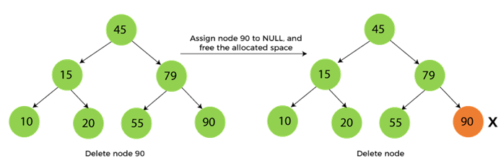
When the node to be deleted has only one child
In this case, we have to replace the target node with its child, and then delete the child node. It means that after replacing the target node with its child node, the child node will now contain the value to be deleted. So, we simply have to replace the child node with NULL and free up the allocated space.
We can see the process of deleting a node with one child from BST in the below image. In the below image, suppose we have to delete the node 79, as the node to be deleted has only one child, so it will be replaced with its child 55.
So, the replaced node 79 will now be a leaf node that can be easily deleted.
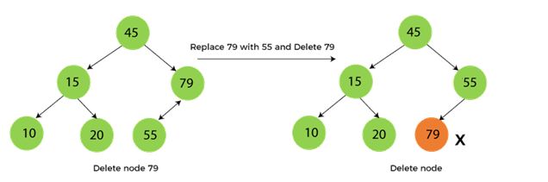
When the node to be deleted has two children
This case of deleting a node in BST is a bit complex among other two cases. In such a case, the steps to be followed are listed as follows -
- First, find the inorder successor of the node to be deleted.
- After that, replace that node with the inorder successor until the target node is placed at the leaf of tree.
- And at last, replace the node with NULL and free up the allocated space.
- The inorder successor is required when the right child of the node is not empty. We can obtain the inorder successor by finding the minimum element in the right child of the node.
- We can see the process of deleting a node with two children from BST in the below image. In the below image, suppose we have to delete node 45 that is the root node, as the node to be deleted has two children, so it will be replaced with its inorder successor. Now, node 45 will be at the leaf of the tree so that it can be deleted easily.
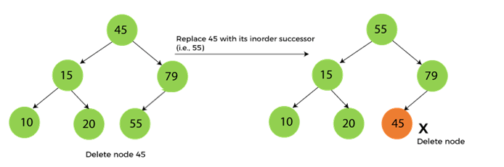
Now let's understand how insertion is performed on a binary search tree.

Insertion in Binary Search tree
A new key in BST is always inserted at the leaf. To insert an element in BST, we have to start searching from the root node; if the node to be inserted is less than the root node, then search for an empty location in the left subtree. Else, search for the empty location in the right subtree and insert the data. Insert in BST is similar to searching, as we always have to maintain the rule that the left subtree is smaller than the root, and right subtree is larger than the root.
Now, let's see the process of inserting a node into BST using an example.
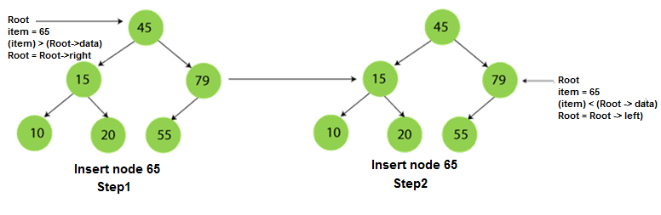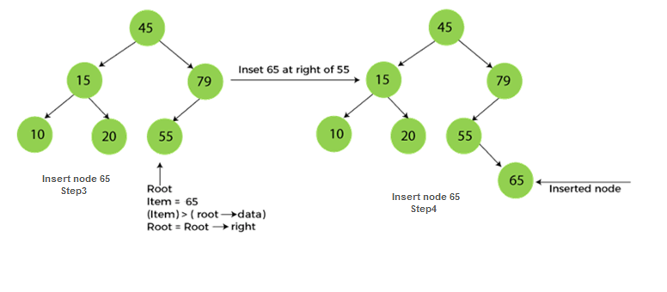

The complexity of the Binary Search tree
Let's see the time and space complexity of the Binary search tree. We will see the time complexity for insertion, deletion, and searching operations in best case, average case, and worst case.

1. Time Complexity
Operations | Best case time complexity | Average case time complexity | Worst case time complexity
Insertion | O(log n) | O(log n) | O(n)
Deletion | O(log n) | O(log n) | O(n)
Search | O(log n) | O(log n) | O(n)
Where 'n' is the number of nodes in the given tree.

2. Space Complexity
Operations | Space complexity
Insertion | O(n)
Deletion | O(n)
Search | O(n)
- The space complexity of all operations of Binary search tree is O(n).

Travelling Sales Person Problem
The traveling salesman problems abide by a salesman and a set of cities. The salesman has to visit every one of the cities starting from a certain one (e.g., the hometown) and to return to the same city. The challenge of the problem is that the traveling salesman needs to minimize the total length of the trip.
Suppose the cities are x₁ x₂..... x_{n} where cost c_{ij} denotes the cost of travelling from city x_{i} to x_{j}. The travelling salesperson problem is to find a route starting and ending at x₁ that will take in all cities with the minimum cost.
Example: A newspaper agent daily drops the newspaper to the area assigned in such a manner that he has to cover all the houses in the respective area with minimum travel cost. Compute the minimum travel cost.

Example of TSP
Here a graph is given where 1, 2, 3, and 4 represent the cities, and the weight associated with every edge represents the distance between those cities.
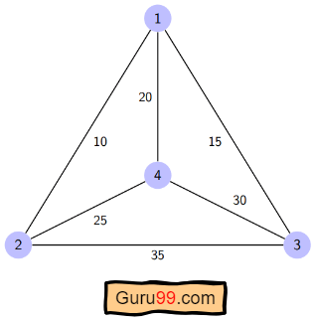

The goal is to find the shortest possible path for the tour that starts from the origin city, traverses the graph while only visiting the other cities or nodes once, and returns to the origin city.
For the above graph, the optimal route is to follow the minimum cost path: 1-2-4-3-1. And this shortest route would cost 10+25+30+15 =80

Algorithm for Traveling Salesman Problem
We will use the dynamic programming approach to solve the Travelling Salesman Problem (TSP).
Before starting the algorithm, let’s get acquainted with some terminologies:
- A graph G=(V, E), which is a set of vertices and edges.
- V is the set of vertices.
- E is the set of edges.
- Vertices are connected through edges.
- Dist(i,j) denotes the non-negative distance between two vertices, i and j.
Let’s assume S is the subset of cities and belongs to {1, 2, 3, …, n} where 1, 2, 3…n are the cities and i, j are two cities in that subset. Now cost(i, S, j) is defined in such a way as the length of the shortest path visiting node in S, which is exactly once having the starting and ending point as i and j respectively.
For example, cost (1, {2, 3, 4}, 1) denotes the length of the shortest path where:
- Starting city is 1
- Cities 2, 3, and 4 are visited only once
- The ending point is 1
The dynamic programming algorithm would be:
- Set cost(i, , i) = 0, which means we start and end at i, and the cost is 0.
- When |S| > 1, we define cost(i, S, 1) = ∝ where i !=1 . Because initially, we do not know the exact cost to reach city i to city 1 through other cities.
- Now, we need to start at 1 and complete the tour. We need to select the next city in such a way-
cost(i, S, j)=min cost (i, S−{i}, j)+dist(i,j) where i∈S and i≠j
dist(i,j) | 1 | 2 | 3 | 4
1 | 0 | 10 | 15 | 20
2 | 10 | 0 | 35 | 25
3 | 15 | 35 | 0 | 30
4 | 20 | 25 | 30 | 0

Let’s see how our algorithm works:
Step 1) We are considering our journey starting at city 1, visit other cities once and return to city 1.
Step 2) S is the subset of cities. According to our algorithm, for all |S| > 1, we will set the distance cost(i, S, 1) = ∝. Here cost(i, S, j) means we are starting at city i, visiting the cities of S once, and now we are at city j. We set this path cost as infinity because we do not know the distance yet. So the values will be the following:
Cost (2, {3, 4}, 1) = ∝ ; the notation denotes we are starting at city 2, going through cities 3, 4, and reaching 1. And the path cost is infinity. Similarly-
cost(3, {2, 4}, 1) = ∝
cost(4, {2, 3}, 1) = ∝
Step 3) Now, for all subsets of S, we need to find the following:
cost(i, S, j)=min cost (i, S−{i}, j)+dist(i,j), where j∈S and i≠j
That means the minimum cost path for starting at i, going through the subset of cities once, and returning to city j. Considering that the journey starts at city 1, the optimal path cost would be= cost(1, {other cities}, 1).
Let’s find out how we could achieve that:
Now S = {1, 2, 3, 4}. There are four elements. Hence the number of subsets will be 2^4 or 16. Those subsets are-
1) |S| = Null:
{Φ}
2) |S| = 1:
{{1}, {2}, {3}, {4}}
3) |S| = 2:
{{1, 2}, {1, 3}, {1, 4}, {2, 3}, {2, 4}, {3, 4}}
4) |S| = 3:
{{1, 2, 3}, {1, 2, 4}, {2, 3, 4}, {1, 3, 4}}
5) |S| = 4:
{{1, 2, 3, 4}}
As we are starting at 1, we could discard the subsets containing city 1.
The algorithm calculation:
1) |S| = Φ:
cost (2, Φ, 1) = dist(2, 1) = 10
cost (3, Φ, 1) = dist(3, 1) = 15
cost (4, Φ, 1) = dist(4, 1) = 20
2) |S| = 1:
cost (2, {3}, 1) = dist(2, 3) + cost (3, Φ, 1) = 35+15 = 50
cost (2, {4}, 1) = dist(2, 4) + cost (4, Φ, 1) = 25+20 = 45
cost (3, {2}, 1) = dist(3, 2) + cost (2, Φ, 1) = 35+10 = 45
cost (3, {4}, 1) = dist(3, 4) + cost (4, Φ, 1) = 30+20 = 50
cost (4, {2}, 1) = dist(4, 2) + cost (2, Φ, 1) = 25+10 = 35
cost (4, {3}, 1) = dist(4, 3) + cost (3, Φ, 1) = 30+15 = 45
3) |S| = 2:
cost (2, {3, 4}, 1) = min [ dist[2,3]+Cost(3,{4},1) = 35+50 = 85,
dist[2,4]+Cost(4,{3},1) = 25+45 = 70 ] = 70
cost (3, {2, 4}, 1) = min [ dist[3,2]+Cost(2,{4},1) = 35+45 = 80,
dist[3,4]+Cost(4,{2},1) = 30+35 = 65 ] = 65
cost (4, {2, 3}, 1) = min [ dist[4,2]+Cost(2,{3},1) = 25+50 = 75
dist[4,3]+Cost(3,{2},1) = 30+45 = 75 ] = 75
4) |S| = 3:
cost (1, {2, 3, 4}, 1) = min [ dist[1,2]+Cost(2,{3,4},1) = 10+70 = 80
dist[1,3]+Cost(3,{2,4},1) = 15+65 = 80
dist[1,4]+Cost(4,{2,3},1) = 20+75 = 95 ] = 80
So the optimal solution would be 1-2-4-3-1
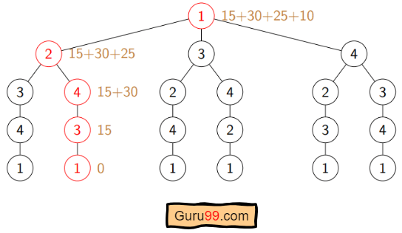

Pseudo-code
Algorithm: Traveling-Salesman-Problem
Cost (1, {}, 1) = 0
for s = 2 to n do
for all subsets S belongs to {1, 2, 3, … , n} of size s
Cost (s, S, 1) = Infinity
for all i Є S and i ≠ 1
Cost (i, S, j) = min {Cost (i, S – {i}, j) + dist(i, j) for j Є S and i ≠ j}
Return min(i) Cost (i, {1, 2, 3, …, n}, j) + d(j, i)

